[](https://www.google.co.uk/url?sa=i&rct=j&q=&esrc=s&source=images&cd=&cad=rja&uact=8&ved=0ahUKEwj6ta-ulvbXAhWFNxQKHaQpBFQQjRwIBw&url=http%3A%2F%2Fwww.thinkstockphotos.com%2Fimage%2Fstock-illustration-panoramic-background-with-school%2F485246172&psig=AOvVaw0MhhpJu2NNhe02nV7YL0gm&ust=1512676799438527)**There is/ There are**

* There is a

[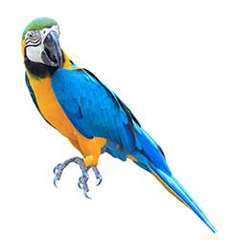](https://www.google.co.uk/url?sa=i&rct=j&q=&esrc=s&source=images&cd=&cad=rja&uact=8&ved=0ahUKEwilovzOlvbXAhXH1hQKHR4bAiYQjRwIBw&url=https://www.collinsdictionary.com/dictionary/english-portuguese/parrot&psig=AOvVaw29NUJemm7zyN2u776GCCHt&ust=1512676867029243)[](https://www.google.co.uk/url?sa=i&rct=j&q=&esrc=s&source=images&cd=&cad=rja&uact=8&ved=0ahUKEwilovzOlvbXAhXH1hQKHR4bAiYQjRwIBw&url=https%3A%2F%2Fwww.collinsdictionary.com%2Fdictionary%2Fenglish-portuguese%2Fparrot&psig=AOvVaw29NUJemm7zyN2u776GCCHt&ust=1512676867029243)

* There are

[](https://www.google.co.uk/url?sa=i&rct=j&q=&esrc=s&source=images&cd=&cad=rja&uact=8&ved=0ahUKEwi5waD7lvbXAhVDuxQKHWsZAaQQjRwIBw&url=http%3A%2F%2Fcliparting.com%2Ffree-bus-clip-art-22415%2F&psig=AOvVaw0_IOZWWqGZUbp288qMeurn&ust=1512676958733393)

* There is a

[](https://www.google.co.uk/url?sa=i&rct=j&q=&esrc=s&source=images&cd=&cad=rja&uact=8&ved=0ahUKEwitnJSFmfbXAhUJ6xQKHYYUATQQjRwIBw&url=https://shop.savethechildren.org.uk/product/football/&psig=AOvVaw2EIyCTjzkxmlieAZy2DCkD&ust=1512677520422413)[](https://www.google.co.uk/url?sa=i&rct=j&q=&esrc=s&source=images&cd=&cad=rja&uact=8&ved=0ahUKEwitnJSFmfbXAhUJ6xQKHYYUATQQjRwIBw&url=https%3A%2F%2Fshop.savethechildren.org.uk%2Fproduct%2Ffootball%2F&psig=AOvVaw2EIyCTjzkxmlieAZy2DCkD&ust=1512677520422413)

* There are

[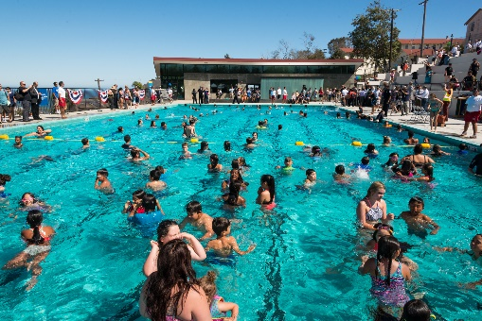](https://www.google.co.uk/url?sa=i&rct=j&q=&esrc=s&source=images&cd=&cad=rja&uact=8&ved=0ahUKEwiJwuvBmvbXAhVGcRQKHUx7BzwQjRwIBw&url=https%3A%2F%2Fla.curbed.com%2F2017%2F6%2F30%2F15900566%2Fsan-pedro-public-swimming-pool-hey-rookie&psig=AOvVaw0CpjJPwAoxVHWTWpTcPWhO&ust=1512677635809377)

* There is [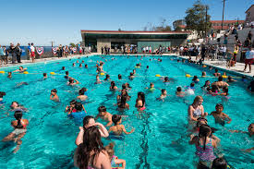](https://www.google.co.uk/url?sa=i&rct=j&q=&esrc=s&source=images&cd=&cad=rja&uact=8&ved=0ahUKEwiJwuvBmvbXAhVGcRQKHUx7BzwQjRwIBw&url=https%3A%2F%2Fla.curbed.com%2F2017%2F6%2F30%2F15900566%2Fsan-pedro-public-swimming-pool-hey-rookie&psig=AOvVaw0CpjJPwAoxVHWTWpTcPWhO&ust=1512677635809377)

a

[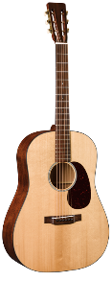](https://www.google.co.uk/url?sa=i&rct=j&q=&esrc=s&source=images&cd=&cad=rja&uact=8&ved=0ahUKEwiZravqmvbXAhUCShQKHc2oClEQjRwIBw&url=https://www.martinguitar.com/guitars/authentic-vintage/d-1-authentic-1931/&psig=AOvVaw0lPShCjPUb4SnJmbHtjTni&ust=1512678001174969)[](https://www.google.co.uk/url?sa=i&rct=j&q=&esrc=s&source=images&cd=&cad=rja&uact=8&ved=0ahUKEwiZravqmvbXAhUCShQKHc2oClEQjRwIBw&url=https%3A%2F%2Fwww.martinguitar.com%2Fguitars%2Fauthentic-vintage%2Fd-1-authentic-1931%2F&psig=AOvVaw0lPShCjPUb4SnJmbHtjTni&ust=1512678001174969)

* There are

[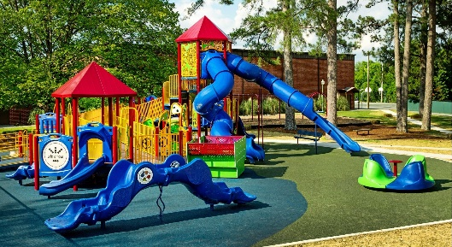](https://www.google.co.uk/url?sa=i&rct=j&q=&esrc=s&source=images&cd=&cad=rja&uact=8&ved=0ahUKEwiLo_66m_bXAhWFxRQKHS_bCU0QjRwIBw&url=https%3A%2F%2Fwww.gametime.com%2Finclusive-playground&psig=AOvVaw1PAFToHaCpMOuLZUVDhlFB&ust=1512678171455990)

* There is a